Assignment 3 – Performance measurements

Context of the assessment
Write your PC specifications here:
Type | Detailed Specs – be as specific as possible
GPU (integrated) | Comet Lake GT2
GPU (dedicated)  specify your available memory | 7.9
CPU | 2.84
Memory (RAM) | 16GB
Storage  Specify free space available | 390GB
Display resolution | 1920x1080

You only have to fill this section once.

Performance assessment #1

Performance Metrics
Type | Measured
Viewpoint screenshot  - Maximize your game  - Take a full screenshot (print screen) | 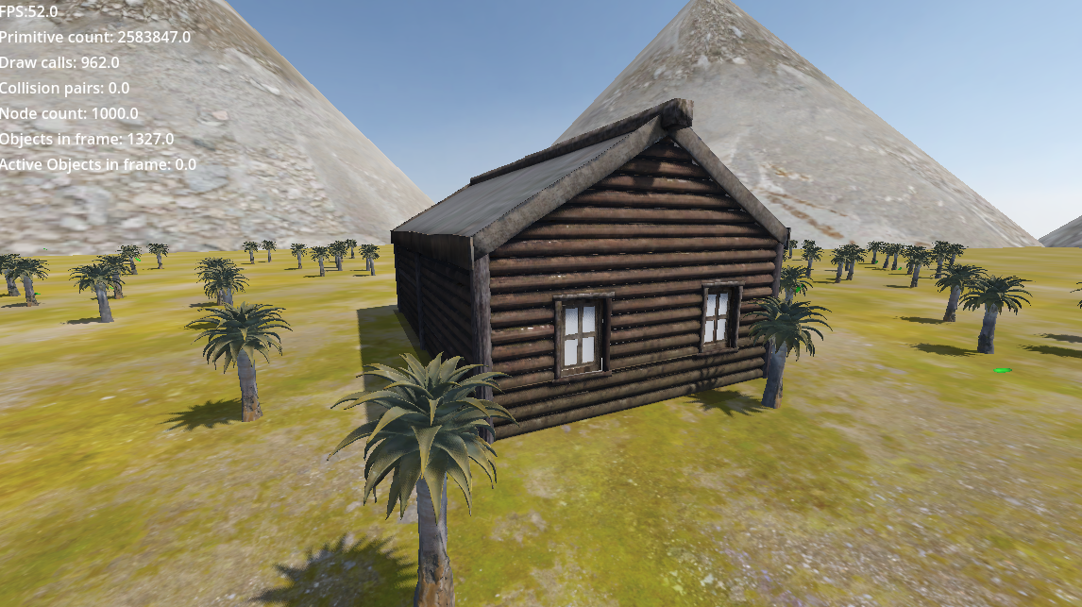
Frames per second (FPS) | 47-50
CPU Time (ms) | 3.2
GPU Time (ms) | 0.5
# objects | 1327
# primitives | 1000
# draw calls | 962
# particle system visible | 1
# light emitters in view | 0
# of physics active objects in scene (requires runtime) | 0
# of collision pairs in view in scene (requires runtime) | 2
Viewport dimensions  (width x height, at runtime) | 1152x648
Git commit hash  Save your current scene in version control | 1c3038aefc89f24be399cf67be6f23a6e4683aae

Identification of the issue
Limiting resource  CPU or GPU | CPU | GPU
Bottleneck issue identified  Explain what you assessed as the main bottleneck and priority to solve | Number of particles was affecting the framerate of the game
Technique used to detect the bottleneck  Ex: Profiler, Visual Profiler, Debugging, Binary search, Hypothesis testing, etc. | Hypothesis testing, by lowering the rate of particles

Optimization technique
Optimization technique used to increase the performance
Ex: LOD, Visibility Ranges, Occlusion Culling, Lowering textures quality, Lowering mesh details, Disabling shadows, etc.
Explain the technique used and how it was applied.
Particle Swarm optimization was applied, by lowering the rate at which the particles spawn and leave

Gained performance
Explain briefly the increase in performance gained after the optimization was made.
Increased FPS

Performance assessment #2

Performance Metrics
Type | Measured
Viewpoint screenshot  - Maximize your game  - Take a full screenshot (print screen) | 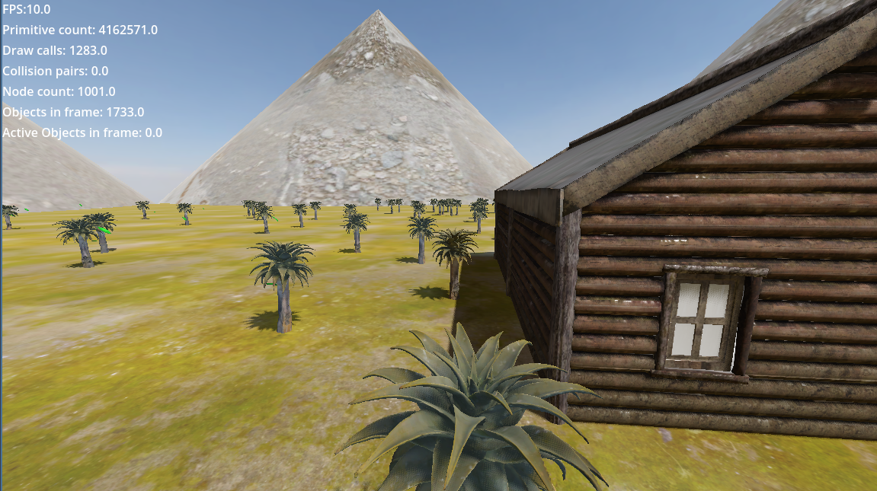
Frames per second (FPS) | 10
CPU Time (ms) | 3.2
GPU Time (ms) | 0.5
# objects | 1733
# primitives | 1001
# draw calls | 1283
# particle system visible | 1
# light emitters in view | 0
# of physics active objects in scene (requires runtime) | 0
# of collision pairs in view in scene (requires runtime) | 2
Viewport dimensions  (width x height, at runtime) | 1152x648
Git commit hash  Save your current scene in version control | 6be2f04103145e3b7c64956db0fa13b55e140203

Identification of the issue
Limiting resource  CPU or GPU | CPU | GPU
Bottleneck issue identified  Explain what you assessed as the main bottleneck and priority to solve | ReflectionProbe causing severe lag spikes
Technique used to detect the bottleneck  Ex: Profiler, Visual Profiler, Debugging, Binary search, Hypothesis testing, etc. | Debugging, removing parts until lag subsided

Optimization technique
Optimization technique used to increase the performance
Ex: LOD, Visibility Ranges, Occlusion Culling, Lowering textures quality, Lowering mesh details, Disabling shadows, etc.
Explain the technique used and how it was applied.
Complete removal, deleted ReflectionProbe as it would always cause severe lag spikes

Gained performance
Explain briefly the increase in performance gained after the optimization was made.
30-40FPS gained, lag spikes removed

Performance assessment #3

Performance Metrics
Type | Measured
Viewpoint screenshot
- Maximize your game
- Take a full screenshot (print screen)

Frames per second (FPS)
CPU Time (ms)
GPU Time (ms)
# objects
# primitives
# draw calls
# particle system visible
# light emitters in view
# of physics active objects in scene (requires runtime)
# of collision pairs in view in scene (requires runtime)
Viewport dimensions
(width x height, at runtime)
Git commit hash
Save your current scene in version control

Identification of the issue
Limiting resource  CPU or GPU | CPU | GPU
Bottleneck issue identified
Explain what you assessed as the main bottleneck and priority to solve
Technique used to detect the bottleneck
Ex: Profiler, Visual Profiler, Debugging, Binary search, Hypothesis testing, etc.

Optimization technique
Optimization technique used to increase the performance
Ex: LOD, Visibility Ranges, Occlusion Culling, Lowering textures quality, Lowering mesh details, Disabling shadows, etc.
Explain the technique used and how it was applied.

Gained performance
Explain briefly the increase in performance gained after the optimization was made.

